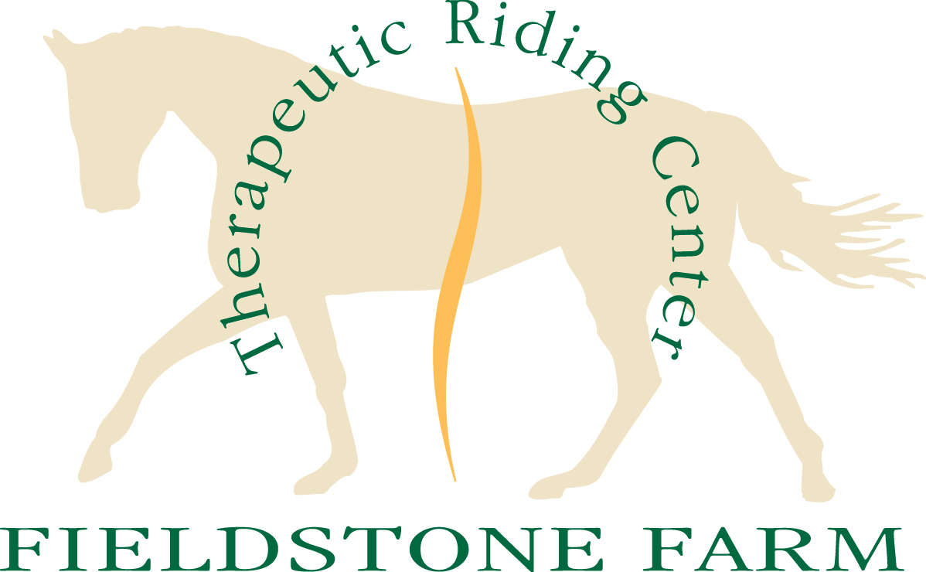

Registered Level Workshop & Certification
August 10-13, 2017

Attend our PATH International OSWC at Fieldstone Farm.

The PATH Workshop is a 2.5 day workshop. All PATH certification candidates are required to complete a PATH Workshop (either this one or a previous one) before being eligible to test for certification. The workshop highlights topics key to therapeutic riding instruction and includes class room instruction, role play and observation.
Date: August 10-12, 2017
Cost: $400

The PATH Registered Instructor Certification begins with candidate riding demonstrations and lesson assignments on the evening of August 12th. On the following day, candidates’ teaching skills are evaluated. Candidates receive their results in private interview the evening of August 13th. To register for Instructor Certification candidates must complete the PATH Registered Instructor on-line testing and submit a copy of the following:
1. Certification Fee
2. A copy of your Instructor ~ In ~ Training confirmation letter from PATH
3. A copy of your PATH Membership card
4. Copies of your CPR and First Aid card

Upon receipt of the above listed items you will receive the PHASE II packet. All materials from the PHASE II packet must be returned to Fieldstone Farm by Monday, July 24, 2017.

Date: August 12(eve) & 13, 2017
Cost: $300

For more information, contact Tonya Zimmer at 440.708.0013 x128 or tzimmer@fieldstonefarmtrc.com.

