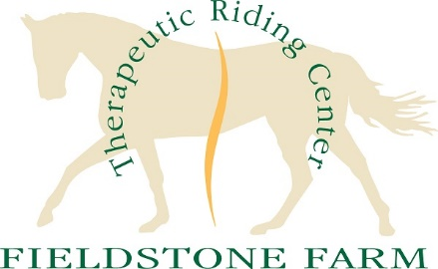
PATH International Driving Demo Only Workshop
August 21st and 22nd, 2021
Hosted by: Fieldstone Farm
The PATH Driving Demo Workshop is a two-day workshop that is open to all PATH members, volunteers or anyone interested in gaining knowledge on Therapeutic Carriage Driving.
The purpose of this workshop is to provide participants with knowledge of the basic components that are utilized by successful, entry-level driving instructors. The two-day workshop will cover topics such as disabilities, teaching techniques, task analysis, class structure, lesson plans, horse analysis, equipment, mounting and dismounting and volunteer management.
The cost of the two-day workshop is $250.00
Saturday from 8:00am to 6:00pm
Sunday from 8:00am to 2:00pm.

Lunch will be provided both days.

REGISTRATION DEADLINE Is July 20th, 2021
PATH International Driving Demo Workshop Registration form.
Name: _______________________________________________________________ (Over 18: Yes No)
Address:______________________________________________________________________________
City____________________________________State_____________________Zip Code________
Home Phone_________________________________ Work/Cell Phone__________________________
Email______________________________________________________________________________
Payment Information
Please make checks payable to: Fieldstone Farm Therapeutic Riding Center
Return this form with payment to: Attn: Lauren Simak, Fieldstone Farm, 16497 Snyder Rd., Chagrin Falls, OH 44023

All payments subject to 60 day/100% refund - 30 day/50% refund - no refund with less than 30 days’ notice. Fieldstone Farm reserves the right to cancel the certification due to health and safety concerns, lack of registrations, or unforeseen circumstances. Fieldstone will fully reimburse candidates if a cancellation occurs.

Need a Hotel?
Spring Hill Suites Cleveland Solon: 3100 Aurora Rd, Cleveland OH 4413
Phone: 1-400-248-9600
Aurora Inn Hotel and Event Center: 30 Shawnee Trail, Aurora, OH
Phone: 1– 330-562-0767

