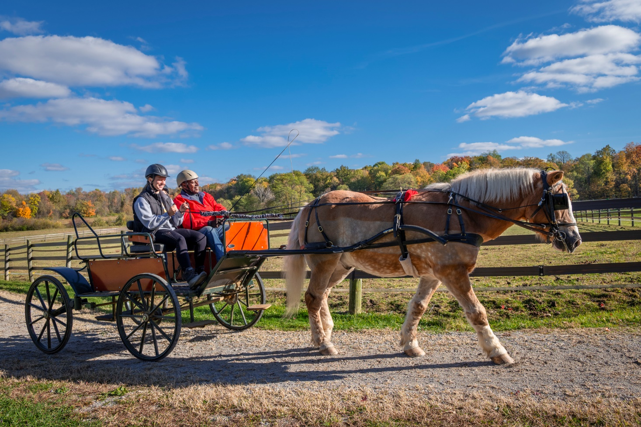

Level 2 Driving Certification
Certification Only
August 20 & 21, 2022

Fieldstone Farm Therapeutic Riding Center
16497 Snyder Road
Chagrin Falls, OH 44023

Join us for this Certification (only) opportunity with evaluators Tina Bennett and Lauren Fitzgerald.

Find out if you are ready to certify here
Registration: $650

Questions: Lauren at LSimak@fieldstonefarm.org

